**DAILY ONLINE ACTIVITIES SUMMARY**

|  |  |  |  |  |  |  |  |  |
| --- | --- | --- | --- | --- | --- | --- | --- | --- |
| **Date:** | **11/6/2020** | | | | | **Name:** | **Banish M G** | |
| **Sem & Sec** | **8th Sem** | | | | | **USN:** | **4AL16CS020** | |
| **Online Test Summary** | | | | | | | | |
| **Subject** | | **SMS** | | | | | | |
| **Max. Marks** | | **60** | | **Score** | | | **60** | |
| **Certification Course Summary** | | | | | | | | |
| **Course** |  | | | | | | | |
| **Certificate Provider** | | | **datacamp** | | **Duration** | | | **4hrs** |
| **Coding Challenges** | | | | | | | | |
| **Problem Statement:**  Python3 program to rotate an array by d elements | | | | | | | | |
| **Status:COMPLETED** | | | | | | | | |
| **Uploaded the report in Github** | | | | | **yes** | | | |
| **If yes Repository name** | | | | | B**anish_MG** | | | |
| **Uploaded the report in slack** | | | | | **yes** | | | |

Online Test Details: (Attach the snapshot and briefly write the report for the same)

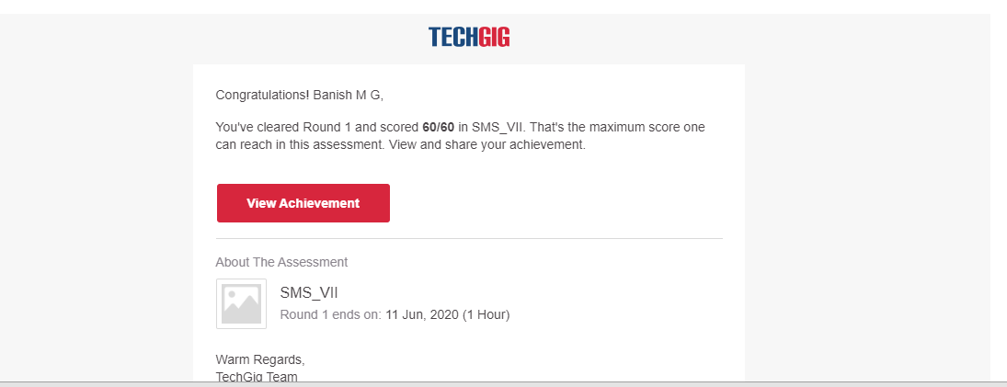

Certification Course Details: (Attach the snapshot and briefly write the report for the same)

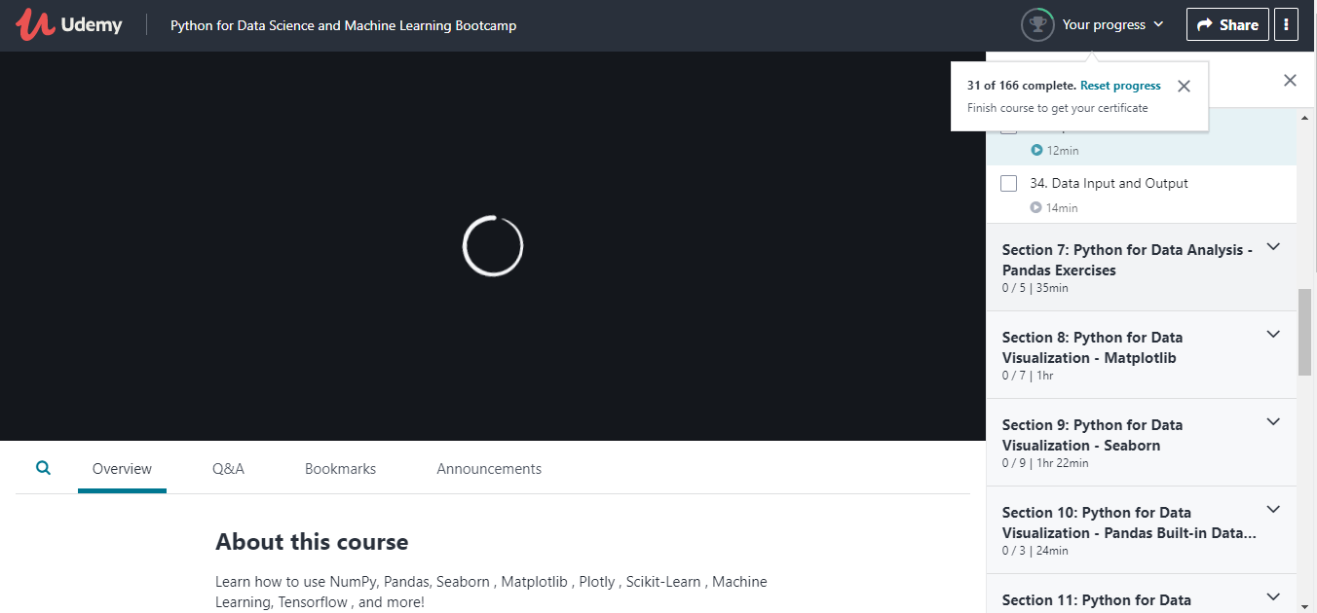

Coding Challenges Details: (Attach the snapshot and briefly write the report for the same)

**Program 1:**

Python3 program to rotate an array by d elements

def leftRotate(ar,d,n):

for i in range(d):

leftRotatebyOne(ar,n)

def leftRotatebyOne(ar,n):

temp=ar[0]

for i in range(n-1):

ar[i]=ar[i+1]

ar[n-1]=temp

def printAray(ar,size):

for i in range(size):

print("%d"%ar[i],end="")

ar=[1,2,3,4,5,6,7]

leftRotate(ar,2,7)

printAray(ar,7)